**P1:- Write a program to draw a pattern given below from 0-9. (max 2 loop allowed)**

**E.g. if n==5**

# * * * #

* # * # *

* * # * *

* # * # *

# * * * #

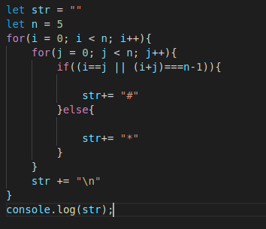

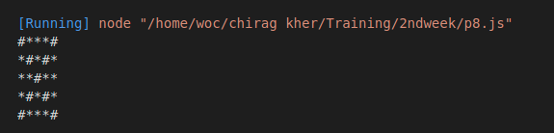

**P2:- Write a program to draw a pattern given below from 0-9. (max 2 loop allowed) [Don't Reveal this one pre handed]**

**E.g. if n==5**

@

@@

@@@

@@@@

@@@@@

@@@@@

@@@@

@@@

@@

@

let n = 7;

let str = ""

for(let i =0; i <=n; i++){

for(let j =0; j <n; j++)

{

if(i+j>=n ){

str += ("@")

}else

{

str += (" ")

}

}

str = str.concat("\n")

}

// console.log(str);

for(let i =0; i <= n; i++){

for(k=0; k < n ; k++){

str+= " ";

}

for(let j =0; j <n; j++)

{

if(i+j<n ){

str += ("@")

}else

{

str += (" ")

}

}

str += ("\n")

}

console.log(str);

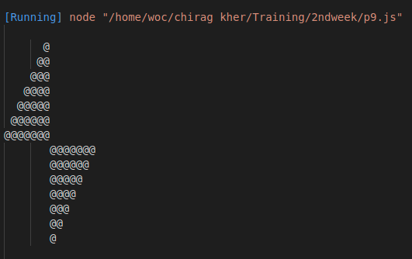

**P3:- Write a program to draw a pattern given below from 0-9. (max 2 loop allowed) [Don't Reveal this one pre handed]**

**E.g. if n==5**

\ - - - /

| \ / |

| o |

| / \ |

/ - - - \

let str = ""

let n = 7

for (i = 0; i < n; i++) {

for (j = 0; j < n; j++) {

if (i == (n - 1) / 2 && j == (n - 1) / 2) {

str += "o"

}

else if (i == j) {

str += "\\"

} else if ((i + j) === n - 1) {

str += "/"

} else if (i == 0 || i == n-1) {

str += "-"

}

else if ( j==n-1 || j == 0) {

str += "|"

}

else {

str += " "

}

}

str += "\n"

}

console.log(str);

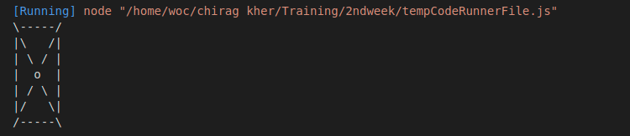

**P4:- Write a program to draw a pattern given below from 0-9. (max 2 loop allowed) [Don't Reveal this one pre handed]**

**E.g. if n==5**

0 0 0 0 0 0 0 0 0 0 0 0 0

0 a b c d e f 5 4 3 2 1 0

0 a b c d e 4 3 2 1 0

0 a b c d 3 2 1 0

0 a b c 2 1 0

0 a b 1 0

0 a 0

0 1 b a 0

0 1 2 c b a 0

0 1 2 3 d c b a 0

0 1 2 3 4 e d c b a 0

0 1 2 3 4 5 f e d c b a 0

0 0 0 0 0 0 0 0 0 0 0 0 0

let n = 5;

let str= "";

for(i=-(n+1); i<=(n+1); i++){

for(j=-(n+1); j<=(n+1); j++)

{

if(i== -(n+1)|| i==n+1 || j== -(n+1) || j==n+1){

str+="o"

}

else if(Math.sign(i) == Math.sign(j) && Math.abs(i) - Math.abs(j)>=0 || j==0)

{

str+= String.fromCharCode((97 + Math.abs(i)- Math.abs(j)))

}

else if(Math.sign(i) != Math.sign(j) && Math.abs(i) - Math.abs(j) >=0)

{

str+= Math.abs(i) - Math.abs(j) +1

}

else

{

str+=" "

}

}

str+= "\n"

}

console.log(str);

